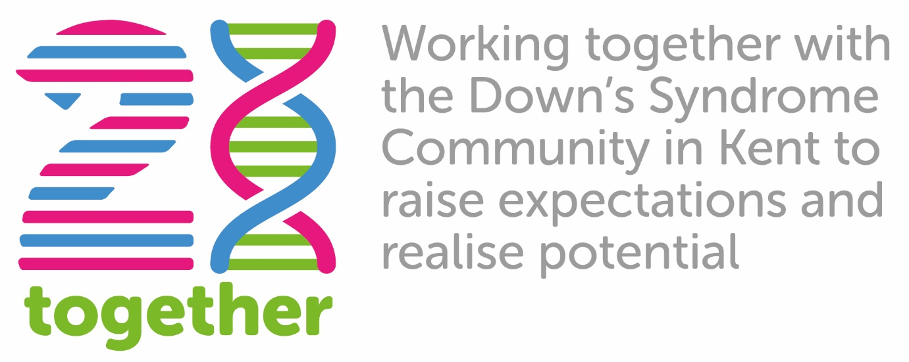

Data Protection Policy

Version: 1
Approval Date: July 2019
Review Date: July 2021

Policy review schedule: Two yearly

The following policy (the “DP Policy”) and any laws that govern Data Protection must be followed by all 21 Together(UOD) employees, volunteers, consultants and trustees who are required to abide by this. This also applies to all third party suppliers processing personal data on 21 Together’s behalf.

This Data Protection Policy sets out how 21 Together will use and protect any information that you as a member, or a third party service provider or contact give to us. 21 Together respects your privacy and is committed to protecting your personal data using high standards of integrity. This DP Policy explains how 21 Together collects, transfers, processes, uses and discloses your personal data and sets out its security practices (Appendix 2).

In providing 21 Together with personal data, you (as a data subject, defined below) agree and consent to the transfer, processing, use and disclosure as outlined in this Data Protection Policy.

This Data Protection Policy is reviewed at least two yearly or earlier if appropriate. This Data Protection Policy may be revised to take account of changes in working practice or applicable law. If so, this Data Protection Policy will be amended.

Principles of the GDPR Act 2016

In order to operate effectively and fulfil its legal obligations, 21 Together needs to collect, maintain and use certain personal data about current, past and prospective members, suppliers and other individuals that contact the UOD, or with whom it has dealings (each, a “data subject” and together, “data subjects”). 21 Together is dedicated to obtaining, handling, processing, transporting and storing all such personal data, whether held on computer, or paper, lawfully and correctly, in accordance with the safeguards contained in the UK GDPR Act 2016 (the “GDPR”). 21 Together has a responsibility to protect such personal data, especially sensitive personal data that it collects from data subjects.

21 Together is committed to the 8 Principles of Data Protection as detailed in the UK GDPR Act 2016.

These principles require that personal data must:
- be fairly and lawfully processed and not processed unless specific conditions are met;
- be obtained for one or more specified, lawful purposes and not processed in any manner incompatible with those purposes;
- be adequate, relevant and not excessive for those purposes;
- be accurate and, where necessary, kept up to date;
- not be kept for longer than is necessary;
- be processed in accordance with the data subject’s rights under the DPA;
- be kept secure from unauthorised or unlawful processing and protected against accidental loss, destruction or damage;
- not be transferred to countries outside the European Economic Area (EEA) unless the country or territory ensures adequate protection for the rights and freedoms of the data subjects.

What 21 Together collects:
21 Together collects personal data that data subjects (you) provide to 21 Together, which is information that can be used (or reasonably be used) to identify someone as an individual. 21 Together will only do this when you (as the data subject) have agreed to a 21 Together request for that personal data. This personal data may include your:
- Name;
- Address;
- Telephone number;
- Email address.
Where a child/young person or adult is attending a group or event we may also collect the following as a means to inform intervention, safeguarding and planning:
- Diagnosis
- Allergies
- Behaviours
- Medical information
- Any other information deemed necessary to provide therapeutic groups, camps and events.

How 21 Together will use a data subject’s personal data.
By providing personal data, you (as a data subject) agree that, where it is permitted
by applicable law or where you have agreed to receive these communications from
us, 21 Together may use your personal data to:
- Respond to your requests;
- Improve services for people with Down’s syndrome ;
- Improve the content of our communications;
- Provide you with tips, helpful information, news and updates;
- Notify you of new services;
- Seek your views on new products and services;
- Consider your application for employment;
- Assist with 21 Together’s own administrative and quality assurance purposes; or
- For other purposes that may be detailed on 21 Together website or a mobile application.

21 Together will act as a data controller of such personal data.

21 Together will only collect personal data to serve a specific business, commercial, or legal purpose and only gather the minimum amount needed. 21 Together will use only fair and lawful means to obtain the personal data.

21 Together will be transparent in dealings with data subjects whose personal data 21 Together holds.

21 Together will obtain a data subject’s informed consent to process his or her personal data in cases where it is necessary and appropriate to do so in compliance with applicable laws.

21 Together will not use personal data collected for one purpose for a different purpose without getting the data subject’s consent, unless applicable laws allow or require it.

21 Together will correct any personal data where it is notified that such personal data is incorrect.

Only authorised paid employees, trustees and volunteers of 21 Together and third party suppliers can carry out processing of personal data, which must be consistent with their individual roles and responsibilities.

Personal data will be held in accordance with the safeguards in 21 Together Security
Guidelines (Appendix 1).

How 21 Together protects your personal data
21 Together will take appropriate legal, organisational, and technical measures to protect personal data consistent with applicable privacy and data security laws. When 21 Together uses a third party service provider, that provider will be carefully selected and required to use appropriate measures to protect the confidentiality and security of personal data.

When we collect your personal information we use strict procedures and security features to prevent unauthorised access. Unfortunately, no data transmission over the Internet is 100 per cent secure. As a result, while we try to protect your personal information, 21 Together cannot guarantee the security of any information you transmit to us and you do so at your own risk.

Sharing personal data with third parties
21 Togethe rmay share the personal data of a data subject in compliance with applicable law.

In certain special cases where permitted by applicable law, 21 Together may disclose your personal data:

- when 21 Together has reason to believe that disclosure of this information is necessary to identify, contact or bring legal action against someone who may be causing injury to you or otherwise injuring or interfering with the 21 Together's rights, property or operations, other users of this website or anyone else who could be harmed by such activities;

- when 21 Together believes that applicable law requires it, or in response to any demand by law enforcement authorities in connection with a criminal investigation, or civil or administrative authorities in connection with a pending civil case or administrative investigation; or Personal data collected may be transferred to, stored and processed in your country of residence or any other country in which the 21 Together, subcontractors or agents maintain facilities, including the United States and countries outside the European Economic Area (EEA).

21 Together will ensure that if your personal data is transferred outside your country of residence, it will still be treated in accordance with this 21 Together Policy.

Unless otherwise specified in the website 21 Together will not sell or license your personal data to other third parties.

Sometimes 21 Together uses selected third parties to provide support services in the normal course of business. These parties may, from time to time, have access to your personal data to enable them to provide those services to the 21 Together. 21 Together requires all third parties providing such support services to meet the same standards of data protection as the 21 Together’s own. Any third party will be prohibited from using your personal data for that third party’s own purposes. In particular, 21 Together will not allow service providers to use your personal data for the marketing activities of that service provider.

Information from Outside Sources
Where permitted by applicable law, 21 Together may also collect legally obtained information from third parties to add to its existing user databases. Some of this information may be personal data of data subjects. 21 Together may do this to better target information offerings and promotional campaigns in which 21 Together believes you would be interested. Such personal data will only be collected and used by 21 Together in accordance with the basis on which it was originally provided by the data subject, or as otherwise permitted by applicable law.

Website and mobile application usage information
21 Together also automatically collects information about your computer browser type and operating system, websites you visited before and after visiting our websites, standard server log information, Internet Protocol (IP) addresses, GPS location data, mobile phone service provider, and mobile phone operating system. 21 Together aggregates this information to understand how visitors to 21 Together websites use the websites so that 21 Together can improve these and the services that 21 Together offers. GPS location data does not typically identify individual users. This information includes:
- the total number of visits to 21 Together websites;
- the number of visitors to each page of 21 Together websites; and
- the domain names of website visitors' internet service providers.

21 Together uses Google Analytics as the main form of website statistics tracking. Any visitors to 21 Together websites who don’t want their data used by Google Analytics can install the Google Analytics optout browser addon. This addon instructs the Google Analytics JavaScript (ga.js, analytics.js, and dc.js) running on websites to prohibit their information from being used by Google Analytics. To optout of Google Analytics for the web, go to https://support.google.com/analytics/answer/181881?hl=en .

Cookies
21 Together website may use technology called "cookies." A cookie is a small text file that is placed on your hard disk by a server. Cookies allow 21 Together website and mobile applications to respond to you, the data subject, as an individual. The website or mobile application can tailor its operations to your needs, likes and dislikes by gathering and remembering information about your preferences. or instance, 21 Together server may set a cookie that keeps you from having to enter a password more than once during a visit to a website.

You can choose to accept or decline cookies. Most web browsers automatically accept cookies, but you can usually modify your browser setting to decline cookies or receive a warning before a cookie is stored if you prefer. Please refer to your Internet browser’s instructions or help screen to learn more about these functions and to specify your cookie preferences.

If you choose to decline cookies, you may not be able to fully experience the interactive features of our websites or any other websites that you visit.

Links to other websites
21 Together’s website may from time to time provide links to or embed third party websites. This 21 Together Policy does not apply to those third party websites. If you choose to enter such a linked site, you agree that 21 Together is not responsible for the availability of such websites and 21 Together does not review or endorse and shall not be liable, directly or indirectly, for:
- how these third party websites treat your personal data;
- the content of such third party websites; or
- the use that others make of these third party websites.

Please ensure you check the data protection policy posted on a third party website
or mobile application you access before entering any personal data.

Use of IP addresses
An IP address is a set of numbers that is automatically assigned to your computer whenever you log on to your Internet service provider or through your organisation's local area network (LAN) or wide area network (WAN). Web servers automatically identify your computer by the IP address assigned to it during your session online. UOD, or third party companies acting on its behalf, may collect IP addresses for the purposes of systems administration and to audit the use of the 21 Together’s website. 21 Together also may use IP addresses to identify users of the 21 Together’s websites when 21 Together feels it is necessary to enforce compliance with the websites’ terms of use or to protect the service, website or other users.

Access to Information / Subject Access Request
21 Together will retain your information only for the period necessary to fulfil the purposes outlined in this 21 Together Policy unless a longer retention period is required or permitted by applicable law. Anyone who is the subject of personal data held by 21 Together has the right to make a subject access request to request the updating, correcting or removal of personal data that has been provided to us, at any time, using the contact information provided at the end of this 21 Together Policy. Applicable laws may also give you the right to access information that you have provided to the 21 Together. 21 Together reserves the right to charge £10 for responding to such requests. If, as the result of a subject access request, any personal data is found to be incorrect it will be amended. 21 Together will deal promptly with subject access requests and will normally respond within 40 days. If there is a reason for delay, the person making the request will be informed accordingly.

Changes
21 Together will update this 21 Together Policy to take account of changes in working practice or applicable law. If the changes that 21 Together makes are material, 21 Together also may post a notice regarding the changes on its websites or mobile applications. 21 Together encourages you to periodically review this 21 Together Policy to stay informed about how 21 Together is helping to protect the personal data that 21 Together collects. Your action in continuing to use 21 Together websites and mobile applications constitutes your agreement to this 21 Together Policy and any updates. Subsequent changes in this 21 Together Policy will not apply to personal data that were collected before the change is made.

21 Together reserves all of its all legal rights.

Contact 21 together

References to “21 Together,” “we,” “us” and “our” are references to 21 Together.

Please address any questions, comments and requests regarding this Data Protection Policy to 21 Together using the contact information below. If you contact 21 Together, please provide information as to how 21 Together may contact you.

To contact 21 Together in the United Kingdom, call 01622230720 or email info@21together.org.uk

Appendix 1

21 Together Suggested Security Practices

- Keep passwords secure – change every three months and do not share.
- Lock/log off computers when away from your desk.
- Dispose of confidential paper waste securely by shredding.
- Prevent virus attacks by taking care when opening emails and attachments or visiting new websites.
- Work on a ‘clear desk basis’ – by securely storing personal information when it is not being used.
- All homeworkers should have a locked cabinet for confidential information.
- Delete personal information in accordance with your department’s record retention schedule.
- Position computer screens away from windows (when relevant and practical) to prevent accidental disclosure of personal information.
- Collect only the personal information you need for a particular business purpose.
- Explain why you are collecting/recording personal information to the subject, obtain their consent and provide an opt out, in line with your departmental practices.
- Update records promptly.
- Delete information no longer required by the 21 Together.
- Do not provide personal information about an employee/member over the phone.

